Manual Instruction

Type: GY4232/70 Horizontal Column Band Saw

NOTE

Thank you for purchasing our product. Manufactured to a high standard this product will, if used according to these instructions and properly maintained, it might give you years of trouble free performance.
IMPORTANT:
PLEASE READ THESE INSTRUCTIONS CAREFULLY. NOTE THE SAFE OPERATIONAL REQUIREMENTS, WARNINGS & CAUTIONS. USE THE PRODUCT CORRECTLY AND WITH CARE.
FOR THE PURPOSE FOR WHICH IT IS INTENDED FAILURE TO DO SO MAY CAUSE DAMAGE AND/OR PERSONAL INJURY AND WILL INVALIDATE THE WARRANTY. PLEASE KEEP INSTRUCTIONS SAFE FOR FUTURE USE.

Contents

1. DESCRIPTION 2
2. UNPACKING and ASSEMBLY 2
3. Installation & ADJUSTMENT 3
4. OPERATION 4
5. blade APPLICATION 6
6. Cooling & lubricating 7
7. Maintenance 8
8. trouble shooting 9
9. Maintenance of main components 10
10. Safety 11
11. appendix 12

- DESCRIPTION
This type is designed to cut off bars and shaped materials.Generally, the hardness of cutting material should be below HRC 35.
To achieve the right function of the saw and the safety of the operator, following data can not be changed in any case:
Model |  | GY4232/70
Power source |  | 460V 3Phase 60Hz
Capacity (inch) |  | ● 12-1/2 ■ 12-1/2×27-1/2
Blade size (inch) |  | 0.05 × 1-1/2 × 183
Blade speed (FPM) |  | 59,128,138,213
Motor Power output | Blade | 4HP
 | Hydraulic | 1HP
 | Coolant pump | 0.12HP
Floor space（L × W × H） (inch) |  | 93× 53 × 55

- UNPACKING and ASSEMBLY

2.1 unpacking
2.1.1. Unpack the saw and inspect all parts. If any parts are damaged contact our sale service.
2.1.2. Unbolt from the transport skid and place on a firm, level surface.
2.1.3. Clean all rust protected surfaces with kerosene, diesel oil, or a mild solvent. Do not use cellulose based solvents as these will damage painted surfaces.

2.2 lifting
At lifting with traveling crane, soft matters shall be padded between the band saw and lifting rope to protect its painted surface from damage. The lifting rope shall be strong and able to withstand twice weight of the saw and keep lifting balance. Cares shall also be taken to surrounding safety.

2.3 Assembly
The saw and accessories requires separately lifting and assembling. Please take care while lifting or assembling. In some cases, the
pulley cover might be separated from the saw in transit, it's important to attach the pulley cover with the screws and washers provided. Close when attached and secure with thumb screw.
Uncivilized unpacking shall not be allowed.
Warning! At lifting of integral box, cares shall be taken to gravity center to avoid inclination; or injury risk would occur.
Note: during the unpacking process, cares shall be taken to plate and nail to prevent injury. The saw shall be prevented from turning over or damaging.
IMPORTANT: ALLWAYS KEEP PROPER FOOTING & BALANCE WHILE MOVING THIS saw!
Use heavy duty fiber belt to lift the saw

- Installation & ADJUSTMENT

3.1 Work field condition
The saw should be installed in the work field that neither obvious vibration source nor dust or dirty. Flat cement foundation is suggested. Keep saw always out from sun, dust, wet, raining area.

3.2 placement
There should be enough space around the saw, widen about 1.5 meters and prepare the cement foundation or wood floor, so that it is convenient to install, test or repair the saw. Connect the base of the saw or roller table with foundation bolts, adjust the holes of iron mounts, put the bolts into the foundation reserved holes, fill in the cement paste, assembly till the foundation is dry and solid.
Notes: A. Around the saw there shall be sufficient space for easy feed and storage of discharged pieces.
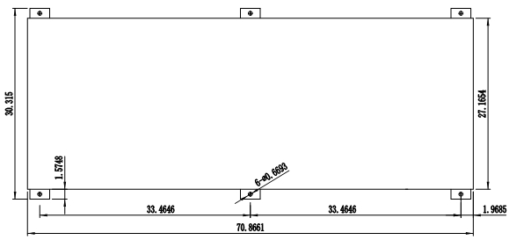
B. Confirm the space for saw repairing, for an example, when the protection door or distribution panel is opened, there would not be any interference.

3.3 Leveling
Adjust the level with level gauge along the worktable orbital direction longitudinal shift, alternatively moving and leveling, adjust the foundation bolts properly till the saw reaches perfect level, fix them finally.

3.4 CLEANING & LUBRICATING
Foundation fig.
3.4.1 This saw might has been coated with anti-rust oil to protect in transit, the coating should be completely removed before operating. Commercial degreaser, kerosene or similar solvent may be used to remove the grease, but avoid getting solvent on belts or other rubber parts.
3.4.2 After cleaning, coat all bright part with a light lubricant. Lubricate all moving parts with a medium consistency machine oil.
3.4.3 hydraulic oil volume
check level gauge of hydraulic oil tank which is an observer fixed beneath electric box at front right of saw base and is easily readable. In case of insufficient oil volume, replenish L-HM32 hydraulic oil (or some other quality oil) till level 2 divisions above
the red mark of the oil level gauge.
3.4.4 Coolant level
Before packing, in order to keep water tank dry, the cooling water is completely discharged.
Immediately before use, cooling water and 5%～8% soap solution shall be added and the cooling water level shall be checked from water level gauge, which is fixed at front left of saw base. During operation, cooling water will constantly flow out.
After completion of daily work, the saw shall be wiped to avoid rust. In case of prolonged shutdown, it shall be coated with anti-rust oil for protection.
Warning: In case of lack of cooling water in water tank, running of cooling water pump shall not be allowed; otherwise it would be damaged.
In case of icing of cooling water in winter, the pump shall not be started. Only after the ice is melted with ca. +10℃ warm water may the pump be started; otherwise the water pump would be damaged.

3.5 connection
Important: The voltage fluctuation must be within +10%.
Choose the right thickness, kind of the wire for the grounding, according to the capacity of the main protector, the way and length of wiring. Either the power or grounding is forbidden to share with any welding machine, so as to avoid any damage to the saw or accidents.
3.5.1 Any distribution job shall be carried out by electricians in accordance with state distribution standards.
3.5.2 TURN OFF power before wiring, and be sure the saw in proper grounding. Overload & circuit breaker is recommended for safety wiring.
3.5.3 Proper cable for connecting the main power source shall be adaptable to the voltage rating adopted in the saw.
3.5.4 Open the safety door of the electrical box. Lead the cable from the general power into the power entrance (Refer to the circuit drawing from appendix). Connect the cable separately with terminal blocks L1, L2 and L3, the ground wire with the terminal PE. Close the safety door .
3.5.6 After connection of proper power source, it's important to check the main power source for correct connection.
3.5.7 Turn on the power switch on the left to the oil tank to (1) position, the indicator on the control panel lights on, and the power source is lined into the saw. Turning off the power switch to (0) position will cut off the power source or urgently stop the saw. Avoid power off during operation work, or unexpected damage might occur to the saw.
Check carefully if the saw blade is running in counter-clockwise direction or not, reverse the wiring per circuit diagram then repeat the running test.
3.5.8 After pressing“Frame up”button, the saw frame will be lifted; otherwise, the main power source shall be checked for correct connection.
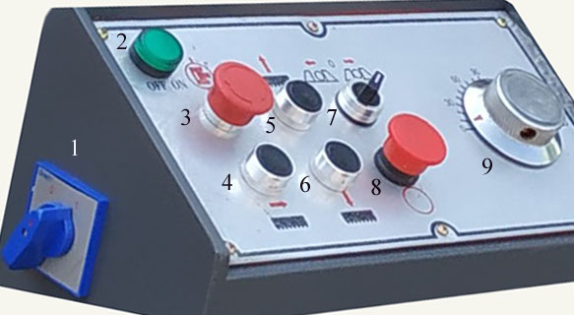
3.5.9 Turn off the power switch, cut off the power source, exchange any two terminals of power source.
3.5.10 Repeat the procedure 3.5.7 to 3.5.10

- OPERATION
WARNING! Before starting the bandsaw ensure that you read, understand and apply the safety instructions.

4.1 OPERATION PANEL
No. | Switch | Function
1 | Power Switch | Turned to ''on" to line in electricity and start the saw, "off" to stop.
2 | Indicator | After switching on the power supply, the indication lamp lights on
3 | Emergency Stop & Hydraulic start/stop | Rotate it to main stop the saw for critical situation.  Press it to to start the hydraulic, press again to stop the hydraulic
4 | Blade Run | After pressing it, the blade motor started, saw wheel rotates and indicator lights on
5 | Frame Up | Pressing it to lift the saw frame, while releasing it will stop
6 | Frame Down(feed) | Pressing it to lower the saw frame normally, while releasing it will stop
7 | Vise Loosing / Clamping | Turn it left to loose the material, right to clamp.
8 | Blade Stop | After pressing it, the blade motor stopped, saw wheel stops and indicator lights off.
9 | Speed control valve | Turn clockwise to increase the speed, anticlockwise to lower.

4.2 Preoperation
Note. It is important that these instructions are followed carefully in order that the saw is started safely and correctly.
Take round material Φ12” for the test
Select the speed of feeding and cutting, as shown in this chapter 4.3. Please reduce the certain speed to half for the first piece, and observe the cutting process. When it works well, gradually increase the speed.
Please open the hydraulic pump and check the pressure, if necessary, adjust it to the standard.
(1) Make sure the blade is suitable for the material to cut. Take the saw blade provided or select a proper saw blade (Refer to Chapter 5.1), please consider the type, shape and spec of the material to cut. (2) Fix the saw blade (Refer to Chapter 5.2). Please make sure there’s a little clearance between the back of saw blade and the rim of the saw wheel. Tension the blade properly.
(3) Check the blade for correct tension and check the blade guide bearings. Make sure the blade guide arm is adjusted as close as possible to the material to cut.
(4) Fill up the tank with hydraulic oil, cooling fluid.
(5) Turn on the main switch of power(No.1). Start the hydraulic(No.3), try every actions and check if there’s any oil spills, run it without any cutting action about 15 minutes. If there is any abnormal occurrence, go to chapter 8 trouble shooting to work out, if you encounter serious problem, please stop the saw at once and contact with our sales service in time. Run again after solving the problem.
(6) Lower saw frame to lower position(No.6), adjust the cutting size accordingly. Then, lift the saw frame to higher position. (No.5)
(7) Place the material between the vises, adjust it for the desired length of cut. Then, clamp the material to be cut (No.7)
(8) Lower saw frame (No.6) till the it is about 2” to the material. Set the upper limit position switch.
(9) Start the saw blades((No.4). Adjust the coolant flow. Observe the cutting process especially for the first piece, if there is any abnormal occurrence, please raise the saw frame(No.5). Start again after resolving the problem.
(10) When the cutting finished, the lower limit position switch will retract automatically, please adjust the high limit position switch and stop the saw. Check the length of the work piece, if necessary, check again after the second piece finished.

4.3 Notes for operation
(1) The new saw blade shall be sharpened before use.
(2) Before connecting the saw to an electrical power system, be sure the motor rating agrees with the electrical system it is to be connected. Make sure the voltage class of the saw is the same as that of end user in the local area. Fuse was recommended to supply power to all machines regardless of their electrical rating. Refer to the electrical schematic drawing from appendix.
(3) Before starting the saw, lubricate the moving parts, including the guide rail, the bearings, and so on. Please clean the hydraulic oil pool, replace the oil according to the requirement of the lubricating system.
(4) The frame lowering speed is adjusted by the flow-rate control valve, the way to proceed the cutting depend on the condition of material, such as the type, hardness, shape, spec., and the condition of blade installed.
(5) It adopts two position four-way solenoid directional valves to control the actions of vises, clamping or loosing. Once the hydraulic pump starts up, the pressure oil goes straightly through clamping cylinder rod-less cavity, if the vise is in loose state, hydraulic pressure will push the vise to move rightwards, and act clamping. Please take care!
(6) Check the shape of chips to judge if the speed of saw blades is appropriate with the cutting. If necessary, adjust accordingly.
Tips: A. Thin or powdered chips: to increase feed rate or reduce blade speed
B. Burned heavy chips: to reduce feed rate and or blade speed.
C. Curly silvery and warm chips: optimum feed rate and blade speed
- loosen the band saw blades after working so as to extend the service life.
- Move the material away, clear chips or other things from the saw. Wipe up the coolant fluid from worktable, guide rails.
Lower the saw frame to the lowest position.
- Cut off the power in case of any accidents before getting off work.
(10) Plan an overhaul for the saw every three years.

4.4 Notes to related devices
- Wire brush The wire brush is fixed in the adjustable cover and during work the saw blade will pass through the wire brush, thereby the iron chips on it will be automatically cleared off. The top of wire brush is fixed with a knurled handle, which may lock and fix the wire brush. After releasing wire brush unit, the wire brush or saw blade may be replaced.
Important! When the margin of wire brush safely contacts but doesn't exceed the saw teeth, the wire brush is properly installed.
Warning! It's important to disconnect the saw from the power source and wear gloves before replacement.
(2) Hydraulic oil level gauge The hydraulic oil is important medium fed to hydraulic system for the normal working and the operator shall frequently watch the indication of the oil level gauge.
The hydraulic oil level shall be 2 divisions above the red mark and when the level is lower than the said value the oil shall be replenished; otherwise the hydraulic system would be unable to work and hydraulic elements would be damaged.
- Oil level gauge of gear box The gear oil is important medium fed to power system for the normal working and the operator shall frequently watch the indication of the oil level gauge. The gear oil shall be kept at middle of red mark and when the level is lower than the said value the oil shall be replenished; otherwise the hydraulic system would be unable to work and the important components of gear box would be damaged.

- blade APPLICATION
CAUTION: BLADE TEETH ARE SHARP, HANDLE WITH CARE.
It is important to choose the suitable band saw blades and the cutting method. We suggest the saw user to take the required cutting condition of material into careful consideration before your choice, such as cutting precision, cutting speed and cutting cost, safety management, and so on.

5.1 selection
The tooth form, tooth pitch of the blades as well as type of that varies with the material, shape, size and fixation methods adopted. Besides, given the same material to cut, various saw blades used for different cutting conditions, such as the cutting precision, cutting speed and cutting cost. Please consult with our sales service and choose the suitable one.

5.2 Installation
- Hang the saw blade onto the driving wheel and passive wheel and through the upper blade guide, working all the way up between the blade guide bearings with the back of the blade against the back-up bearings.
- Put light tension on the blade and work onto both wheels, ensure the back of the blade is against the flanges of both wheels.
- Adjust blade to the final tension. Proper tension is achieved when the pointer is on the left mark of the blade tension scale behind the idle wheel.
- Release the wire brush locking unit to lift the wire brush to make it cover the saw teeth.
- Adjust the height of wire brush to make it just contact bottom of saw teeth.
- Connect the saw to the power source and turn it on and off about two or three times to ensure the blade is seated and tracking properly. When finished close the wheel covers.

5.3 Replacement
- Disconnect the saw from the power source.
- Raise the saw frame about 5.9”.
- Slide the left blade guide arm to the right as far as it will go.
- Open both wheel covers and clean chips out of the saw.
- Release blade tension by unscrewing the blade tightening handle
- Remove the blade from both wheels and out of the blade guides.
- Make sure the teeth of the new blade are pointing in the right direction (teeth pointing down).
- Place the blade on the wheels, in the blade guides and adjust it, then tension the blade.

- Cooling & lubricating
It includes the coolant pump, pipeline, joint, tap and cooling pool. Proper cutting fluid is essential to obtain maximum efficiency from a band saw blade. The main cause of tooth failure might be excessive heat build-up. Cutting area and blade wheels should be kept clean at all time. The rate of coolant flow is controlled by the tap.
Tips:(1) Lubricate the moving parts before or after running the saw, such as the column guide rail, the worm gear, the lead screw under the vises, the slanting-roll lead screw and so on. It’s necessary to lubricate the saw every workday.
- After 3 months of working, it’s necessary to clean the hydraulic oil tank replace the hydraulic oil and the lubricating oil for the bearing of the pulley.
Lubricating reference
No. | Position | Type of oil | Cycle(per shift) | Method
1 | bearing of the pulley | grease | once | oil gun
2 | bearing below the lifting cylinder | grease | once | oil gun
3 | guide rail of the tension device | grease | once | oil gun
4 | guide head | grease | once | oil gun
5 | bearing above the worm gear box | grease | once | oil gun
6 | rolling bearing of the guide device | engine oil | once | oil can
7 | lead screw and the sliding surface of the movable vise | engine oil | once | oil can
8 | worm gear box | hypoid gear oil | once | Oil bath
9 | axle of the lifting or lowering of the saw frame | engine oil | repeatedly | oil cup
Fluid related
- Hydraulic oil
If you start the pump without enough hydraulic oil, the pump and motor would be damaged, please make sure that there is enough hydraulic oil before starting the saw.
Make sure the level of hydraulic oil reach the middle of the oil level. If not, add oil through the oil filler.
Please use quality anti-wear hydraulic oil, such as L-HM32
Change the hydraulic oil once a year.
Temperature Limit of Hydraulic oil
15-0℃: Low High-viscosity if it's below 15℃
30-20℃: PropeR Suggested 20℃, highest performance, longest operating time enabled
55-30℃: Available
80- 55℃: limited operating time shortened, requires oil cooler. As it rises by 8℃, the time shortened by half.
100- 80℃: dangerous Forbidden!

- Cutting fluid
If you start the pump without enough cutting fluid, the pump and the motor would be damaged. Make sure that cutting fluid is enough before saw started. The cooling fluid added to the cutting fluid tank upside the chips tank.
The ratio of cutting fluid dilution with water about 1:20, adjusted according to the processing requirement.
The cutting fluid should be changed at least once per 6 months, the cooling system cleaned as well.
- Gear oil
Make sure that the oil level is between the up and down limit. If not, the gear oil should be filled up to the proper level.
The gear oil should be changed once per year, or after the first 300 hours of using from the gear box.

- Maintenance
WARNING! Before carrying out any maintenance ensure that the saw is powered off, isolated from the main supply and that the blade is at a complete standstill. Failure to comply with this instruction can cause serious injury.

7.1 checking points
(1) The position of wire brush to ensure thorough clearing off chips from teeth groove, and, if necessary, adjust or replace the wire brush. Check its height to make it just contact with but not exceed the bottom of saw teeth to avoid excessive wearing out of
saw blade or wire brush.
(2) The indication of gear box and hydraulic oil level gauge, replenish gear oil or hydraulic oil, in case of oil shortage
- The indication of cooling water level gauge to decide replenishing or not.
- Correct position of the saw blade from the driving, passive wheel and the blade guides.
- The saw blade tension state
- The gear box tension belt.
- Clearing the chips from driving and passive wheel for new saw blade installation

7.2 Cleaning and replacement
7.2.1 General cleaning
WARNING! Do not use compressed air to clean the saw as metal filings may blow into the blade guide bearings and other critical areas. Dangerous while the flying particles released into the surrounding area.
Keep all surfaces clean and free of rust, chips, and coolant build-up. After completion of daily work, the saw shall be cleaned and wiped. Use a small paint brush or parts cleaning brush to remove metal particles. If inaccessible (and ferrous) use a magnetic pick-up tool. Regularly wipe the saw down with a clean dry cloth and protect all unpainted surfaces with light machine oil.
Keep blade guides clean and free of metal filings.
7.2.2 Replacement of wire brush
Important! Incorrect installation of wire brush would result in excessive wearing out of wire brush or instable cutting.
Proceed as follows:
a. Turn off the power switch. Release knurled handle and wire brush unit
b. Loose the wire brush set nut on the driving spindle and take out the wire brush
C. Fix new wire brush and fix it with nut. The top of the wire of the fixed wire brush shall safely contact with but not exceed the
tooth of the saw blade and then the brush is locked
7.2.3 Replacement of cooling water
Under normal use, the cooling fluid shall be replaced and chips shall be cleared off from water tank every 3 months. Proceed as follows:
a. Turn off the power switch. Open the sealing plug of the water tank to dry the cooling fluid, and re-fix the sealing plug
b. Take out filter net cover
c. Clear the chips from the water tank, and wipe it with cotton cloth
d. Fill the tank with cooling fluid and running water
7.2.4 Replacement of hydraulic oil
The hydraulic oil shall be replaced every 5 years. Proceed as follows:
a. Turn off the power switch. Take out hydraulic oil drain plug from saw bottom and make hydraulic oil flow to proper container.
Note: The hydraulic oil may be pumped from oil tank to another container as anti-rust oil.
When the oil tank is emptied, it shall be cleaned with the same type of clean hydraulic oil, and it can’t be cleaned with kerosene. It may be cleaned with hot oil (80℃), in this case effective oil filter shall be fixed and all elements shall simultaneously work.
b. Inject the L-HM32 hydraulic oil into the oil tank through filter, till it approaches 2 divisions above the red mark.
Wipe anywhere might be dropped with hydraulic oil.
7.2.5 Replacement of gear oil
After every 6 months or 1200 hours the gear oil shall be replaced. Proceed as follows:
- Turn off the power switch. Open oil drain plug of gear box, discharge gear oil, re-fix the oil drain after that
- Open oil-filling plug. Inject the new gear oil till it approach 2 divisions above the red mark on the oil level gauge.
- Re-fix oil-filling plug
7.2.6 Oil cup on slide sleeve
Daily fill oil cup with machine oil, and adjust nut of the oil cup to make oil evenly lubricate vertical main tube.
- trouble shooting
Problem | Causes | Solution
saw blade falls | 1.the blade is loose.  2.the passive pulley is not parallel | 1.tension the blade properly.  2.adjust the 3 groups of screws behind the passive pulley to locate the blade.
Strange noise from the worm gear box | 1.the axial clearance between the worm wheel and worm is too big .  2.two pairs of bearings are worn out. | 1.adjust the axial clearance  2.replace bearings.
saw frame lifting failure | - the oil pressure is not enough.  2.the valve for lifting doesn’t work.  3.if the upper limit position switch is reset  4.the oil pipe draws in air or locked. | 1.check the pressure, adjust the relief valve  2. check the circuit, pipeline.  3.check the upper limit position switch.  4.clean, change the filter or the valve
saw frame lowering failure | 1.the speed control valve is blocked.  2.the speed control valve doesn’t work  3.the lower limit position switch is reset  4. the back pressure is too high. | 1.check and clean the valve.  2.check the circuit, pipeline.  3. check the lower limit position switch.  4. adjust the pressure to the standard.
saw frame is shaking or producing strange noise when cutting | 1.the gap between the column and the sliding bush is too big.  2.the speed is not suitable.  3.the gap between the blade and the guide blocks is too big. | 1.replace the copper bush.  2. adjust the speed.  3.adjust the guide blocks.
Serious deviation of the work piece | 1.high speed applied  2.the saw teeth is passivated, or the dividing is asymmetric.  3.space of the two guide arms is too big.  4.the saw blade is not well tensioned.  5.guide blocks are not well adjusted.  6.the band of blade is not vertical to the face of work table or the fixed vise. | 1.reduce the speed.  2.replace the saw blade.  3.adjust the space  4.tension the blade.  5.adjust the guide blocks  6.adjust the guide arms to make sure the band is vertical with the worktable and the fixed vise.
Power switch is on, but indicator unlit | 1.the power is lack of phase.  2.the fuse is broken. | 1.check the main power circuit.  2.replace the fuse.
Noise from oil pump | the filter net is blocked or the oil is badly absorbed | Clean the filter net
Hydraulic oil goes foamy | 1.the oil is not enough.  2.the inlet pipe leaks.  3.the return pipe is above the surface of oil. | 1.add the oil.  2.repair the pipe.  3.lower the return pipe below the surface of oil
- Maintenance of main components

9.1 Main driving system
It is made up of blade motor, worm gear box, driving pulley system, passive pulley system . The saw gains 3-step speed through the triangle belt.

9.2 The hydraulic sYSTEM
It is made up of the oil pump, hydraulic motor, valves, cylinder, oil tank, the pipeline. (Refer to the appendix)

9.3 The electrical system
It is made up of the main motor, hydraulic motor, cooling motor, position switch, distribution box, operation panel, electrical elements, cable and so on . (Refer to the appendix)

- Safety

10.1 Safety rules
- Adhere to the safety rules during work.
- The power source voltage must not exceed +10% of the electrical equipment voltage to avoid any damage.
- Don’t wear gloves when operating.
- Wear tight clothes, anti-slip footwear.
- It’s forbidden to modify the electric circuit or parts, so as to avoid any damage to the saw or the operator.
- The relative position of two guide arms and the movable vise should be adjusted to avoid any collision to the arm or vise while the saw frame moving downwards
- Cut off the power before any repairing or maintenance to the saw.
- Don’t operate the saw on assumptions. Don’t operate the saw being absent-minded even forget part of your body still against the saw.
- Don’t operate the saw until you make sure the security, right way to operate, there is no obstacles around.
- Don’t start cutting until you are sure the work piece is tightly clamped. It’s necessary to use the special fixture to clamp while cutting irregular-shaped materials, otherwise, the material might fall or fly off and cause danger.
- It’s necessary to take anti-down measures before cutting thin or short material, otherwise, the work piece might fall down, rolls out, and cause danger.
- Please set the roller racks in the front and rear of the saw before cutting long material. Otherwise, the work piece might fall down and cause danger while being cutting or cutting finished.
- It’s forbidden to operate the saw when the belt cover is open or taken off.
- When the blade is running, don’t adjust the wire brush or clear the chips, so as to avoid any danger to your hands.
- Do stop the saw before do the cleaning, otherwise, part of your body or the tool might be involved in and cause danger.
- It’s dangerous to stand on the roller conveyor, or you might fall down.
- This saw utilize water-soluble cutting fluid. The oily fluid might cause smoking or fire during cutting. There should be a fire extinguisher in the vicinity of the saw as well as a fire alarm. The saw must not be left operating.
- Don’t touch the blades when it is running, otherwise, your hands might be involved into the saw.
- Chips of titanium or magnesium might catch fire easily, please don’t smoke when cutting these materials, and There should be a fire extinguisher in the vicinity of the saw as well as a fire alarm. The saw must not be left operating
- Don’t cut carbon rod on this saw, or the chip will reduce to powder, send into the air, and make the air into combustible qualitative. If it meet the electric arcs, electric spark arise fire sparkles, caused by the running motors of the saw, it will catch fire or explode. Special measures must be carried out while cutting materials like carbon rod.

10.2 Warning signs
Follow the rules mentioned for the symbols and signs, keep them legible, if damaged, restore them to their original state.

Label | Note
 | Read and understand the instruction manual before operating the machine. Work only with protective gloves.
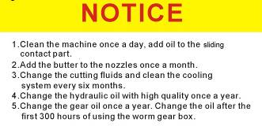 | - Clean the machine once a day, add oil to the sliding contact part. Add the butter to the nozzles once a month. 2.Change the cutting fluids and clean the cooling system every six months. 3.Change the hydraulic oil with high quality once a year. 4.Change the gear oil once a year. Change the oil after the first 300 hours of using the worm gear box.
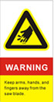 | Keep arms, hands, and fingers away from the saw blade.
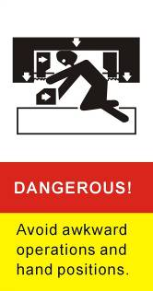 | Avoid awkward operations and hand positions.
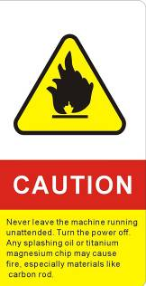 | Never leave the machine running unattended. Turn the power off. Any splashing oil or titanium magnesium chip may cause fire, especially materials like carbon rod.
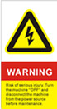 | Dangerous! Risk of serious injury. Turn the machine ''OFF'' and disconnect the machine from the power source before maintenance.
- appendix
Bearings list
Name | Model | Qty. (pcs ) | Location
deep groove ball bearing | 6202 | 4 | guide head
deep groove ball bearing | 6207 | 4 | roller
deep groove ball bearing | 6208 | 1 | Worm shaft
taper roller bearing | 30307 | 2 | Worm shaft
taper roller bearing | 30212 | 2 | Axis of worm gear
cylindrical roller bearing | NJ211E | 1 | Axis of worm gear
cylindrical roller bearing | NJ212E | 1 | Axis of worm gear
cylindrical roller bearing | NJ208E | 2 | driven saw wheel pulley
thrust ball bearing | 51104 | 1 | screw rod for tightening
Spare part list
Wire brush Φ75 | 1pc
Carbide pads | 1set
V-belt 1295A | 1pc

Hydraulic drawing, schematic sheet and part list
Name | Model | Qty.(pcs)
Filter net | WU3-Z160×160F-S | 1
Vane pump | YB1-6B3 | 1
Hydraulic motor | 0.75kw | 1
Pressure gauge | Y-60 | 1
Directional control valve | DSG-02-3C2 | 2
Directional control valve | DSG-02-2B11B | 1
Relief valve | P-B10B | 1
Speed control valve | Q-10B | 1
Pressure gauge switch |  | 1

Cylinder for the saw frame for the vise

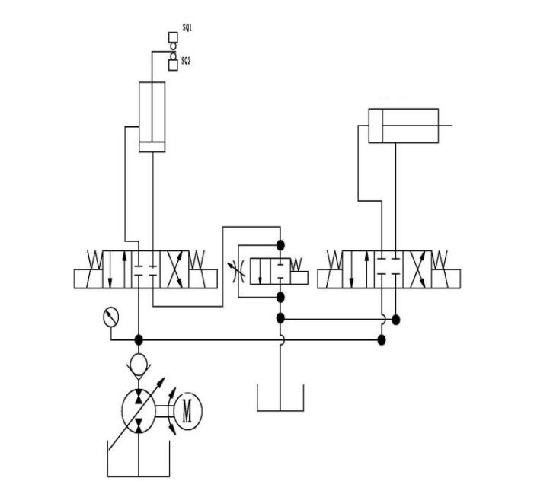
 | Saw frame |  |  | Vise
 | Up | Fast Down | Feed | Close | open
YA1 |  |  |  |  | +
YA2 | + | -
YA3 | - | +
YA4 |  |  | +

Electrical schematic drawing, part list

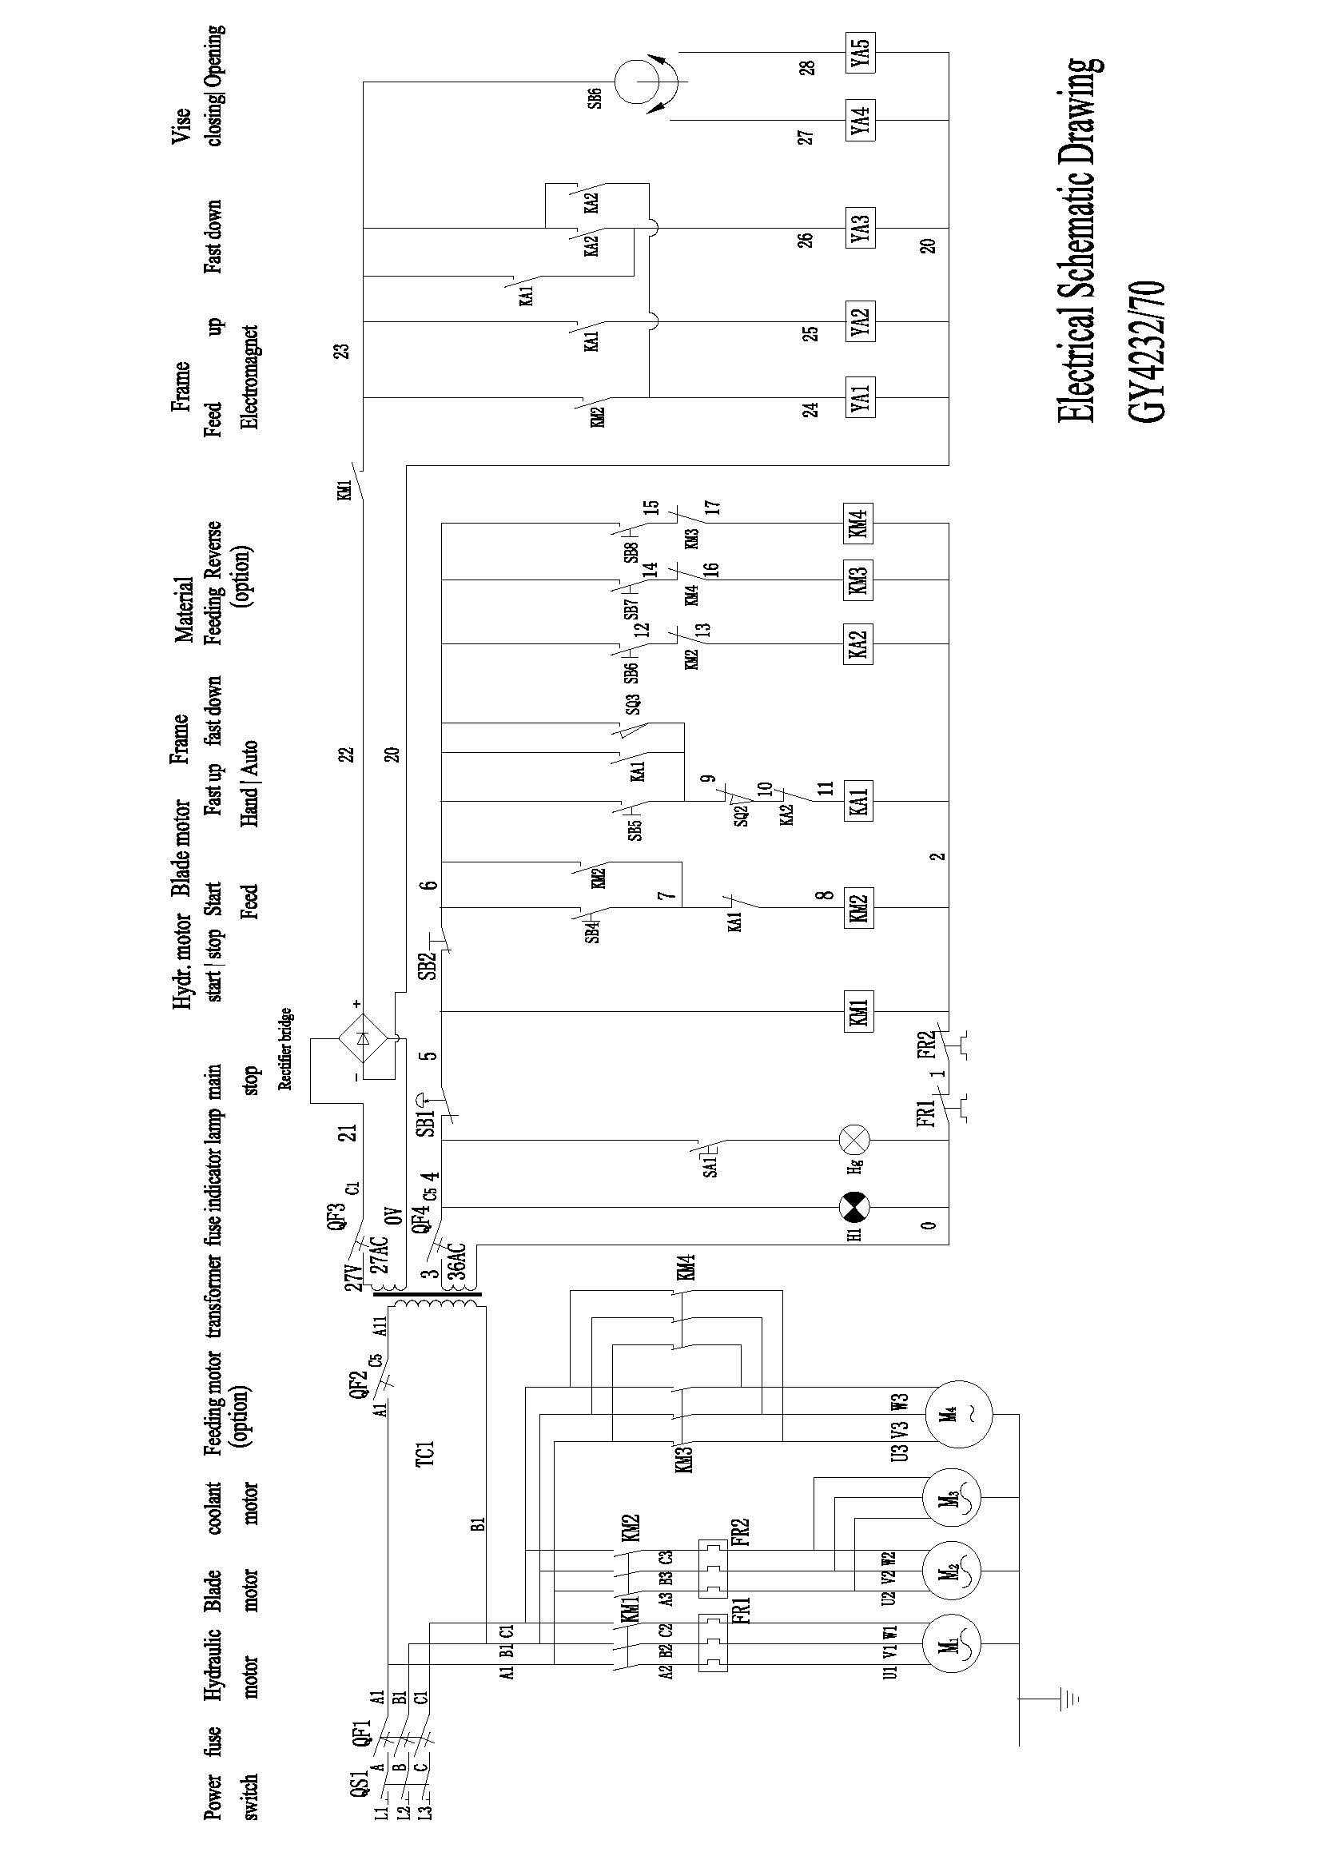

Mark | Name | Model | Qty.(pcs)
M1 | Hydraulic motor | 0.75KW | 1
M2 | blade motor | 3kw | 1
M3 | Coolant motor | 0.09kw | 1
TC1 | Transformer | BK-150 | 1
QF | Power switch | HZ10-25/3 | 1
KM1 | AC contactor | CJX2-1210 | 1
KM2~4 | AC contactor | CJX2-1210 AC36V | 3
MA1 | Middle contactor | JZC4-22 AC36V | 1
FR1 | Thermal overload relay | JR36-20 /5A | 1
FR2 | Thermal overload relay | JR36-20 /16A | 1
QF1 | Breaker | DZ47-60/C20 | 1
QF2~3 | Breaker | DZ47-60/C5 | 2
SB1 | Emergency stop button | LAY16 A4 | 1
SB6 | Knob Button | LAY16 D | 1
SB3~7 | Button | LAY16 A | 3
SB2 | Key button | LAY16 C | 1
Hg | Lamp | JC4-1 AC36V | 1
H1 | Indicator | XDJ2 AC36V | 1
KLX1~2 | Position switch | YBLX-K1/411 | 2
 | 12 bit terminal block | TD-2512L | 2
 | 4 bit terminal block | LTD-2504 | 1

Partial detail of band saw figure
Fig. No. | Part name | Fig. No. | Part name
1 | Saw frame | 1-1 | Saw frame
2 | Main column | 1-2 | Beam
3 | Electric cabinet | 1-3 | Band tighten seat
4 | Sub-column | 1-4 | Driven saw wheel
5 | Hydraulic cylinder for frame up/down | 1-5 | Top cover of driven saw wheel
6 | Sliding block to hydraulic cylinder | 1-6 | Cover of driven saw wheel
7 | Base | 1-7 | Band guide arm
8 | vise set | 1-8 | Band guide head
8-1 | Fixed vise | 1-9 | Big shim
8-2 | Movable vise | 1-10 | Column bush
8-3 | Medium plate for material support | 1-11 | Worm gear box
8-4 | Receiving plate | 1-12 | Blade motor
8-5 | Bearing seat | 1-13 | Belt pulley
8-6 | Bearing | 1-14 | Cover of belt pulley
8-7 | Vise body | 1-3-1 | nut
8-8 | roller | 1-3-2 | Spring shim
8-9 | Sliding block for clamping | 1-3-3 | Flat shim
8-10 | Screw rod | 1-3-4 | Big flat shim
8-11 | Hydraulic cylinder for clamping | 1-3-5 | Band tighten seat
8-12 | Extension bar | 1-3-6 | Axis of driven saw wheel
8-13 | Hand wheel | 1-3-7 | Bearing housing
1-11-1 | nut | 1-3-8 | Plane bearing
1-11-2 | Top cover to worm shaft | 1-3-9 | Flat shim
1-11-3 | Adjusting shim to worm shaft | 1-3-10 | Screw rod for tightening
1-11-4 | bearing | 1-3-11 | Sliding block
1-11-5 | Worm shaft | 1-3-12 | Layering
1-11-6 | circlip | 1-11-14 | Worm gear box
1-11-7 | oil leveler | 1-11-15 | Oil seal seat to worm shaft
1-11-8 | Flat key | 1-11-16 | Oil seal
1-11-9 | Oil seal seat to worm gear | 1-11-17 | Top cover to worm gear
1-11-10 | Flange | 1-11-18 | Adjusting shim to worm gear
1-11-11 | Bearing | 1-11-19 | Grease fitting
1-11-12 | Axis of worm gear | 1-11-20 | Vent hole
1-11-13 | Worm gear

General cutting Chart
Material | Similar Steel Grade |  |  |  | Speed  (ft/min) | Cutting Rate  (in²/min)
 | GB | AISI | DIN | JIS
Low carbon steel | 08 | 1010 | C10 | S10C | 183 | 10.85-12.4
 | 15 | 1015 | C15 | S15C | 183 | 10.85-12.4
medium carbon steel | 45 | 1045 | C45 | S45C | 226 | 9.3-10.85
 | 55 | 1055 | CK55 | S55C | 226 | 7.75-9.3
Tool steel | T10 | W1 | C75W | SK4 | 134 | 3.1-6.2
 | T12 | W1 | C125W | SK2 | 134 | 4.65-6.2
Tool steel | T8Mn | W1 | C80W | SK5 | 98-131 | 4.65-6.2
Alloy steel | 40CrNi | 3140 | 40NiCr6 | SNC236 | 134-183 | 4.65-6.2
 | 40CrMoA | 4140 | 42CrMo8 | SCM440 | 134-183 | 5.27-6.975
 | 40CrNiMoA | 4340 | 34CrNiMo8 | SNCM439 | 134-183 | 4.65-6.2
High Speed Steel | W18Cr4V | T1 | S18-3-1 | SKH2 | 91 | 3.1-6.2
 | W18VrVo5 | T4 | S18-1-2-5 | SKH3 | 91 | 2.325-3.875
Cold die steel | Cr12MoV | D2 | X15CrVMo121 | SKD11 | 91 | 3.1-3.875
Cold die steel | CrWMn | D7 | 105WCr6 | SKS2 | 91 | 2.325-3.1
 | 9SiCr | D1 | 105WCr6 | SKH3 | 91 | 2.325-3.1
Hot die steel | 4Cr5MoViSi | H13 | X40CrMoV51 | SKT61 | 91-134 | 3.875-4.65
 | 5CRNiMo | L6 | X55NiMoV51 | SKT4 | 91-134 | 3.1-3.875
 | 3Cr2W8V | H21 | X30CrMoV51 | SKD5 | 91-134 | 4.65-5.425
Spring steel | 50CrVA | 6150 | 50CrV4 | SUP10 | 91 | 3.1-4.65
 | 50CrMnVA | 6150 | 50CrV4 | SUP10 | 91 | 3.1-4.65
Stainless steel | 0Cr17Ni12Mo2 | 316 | X5CrMiMo1721 | SU316 | 91 | 2.325-3.875
 | 1Cr17 | 430 | X6Cr17 | SU430 | 91 | 2.325-3.875
Bearing steel | GCr15 | S2100 | 100Cr6 | SUJ2 | 91-134 | 3.875-5.425

